BAR CHART

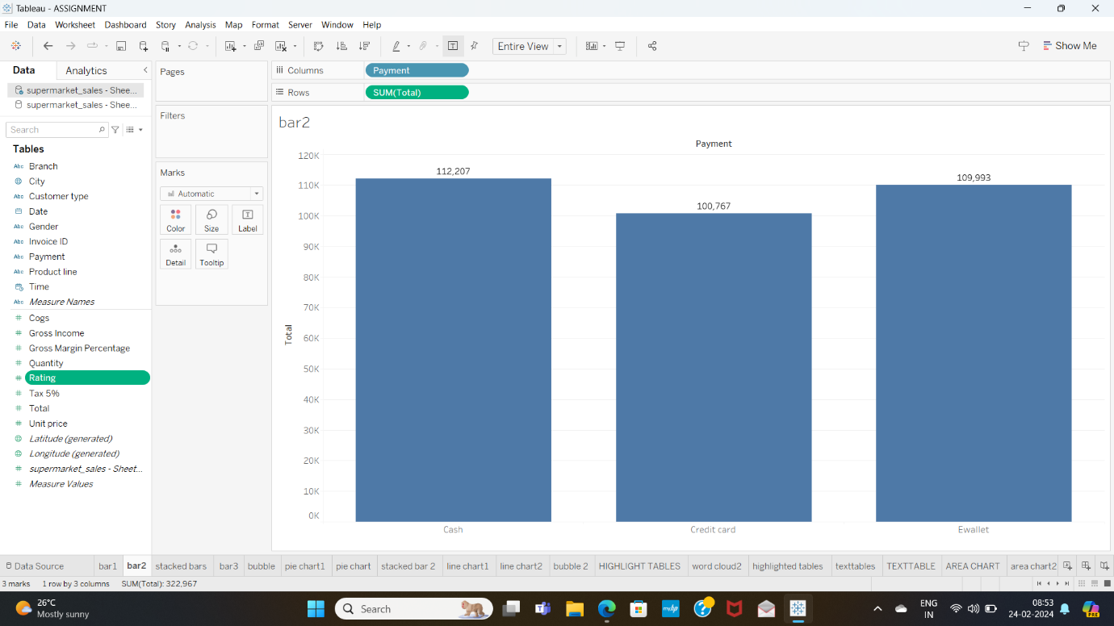

I have made this visualisation using supermarket sales dataset.

To know the total payment of customers through cash ,credit, and debit card . The payment is high through the cash and then credit , and debit card.

STACKED BAR CHART

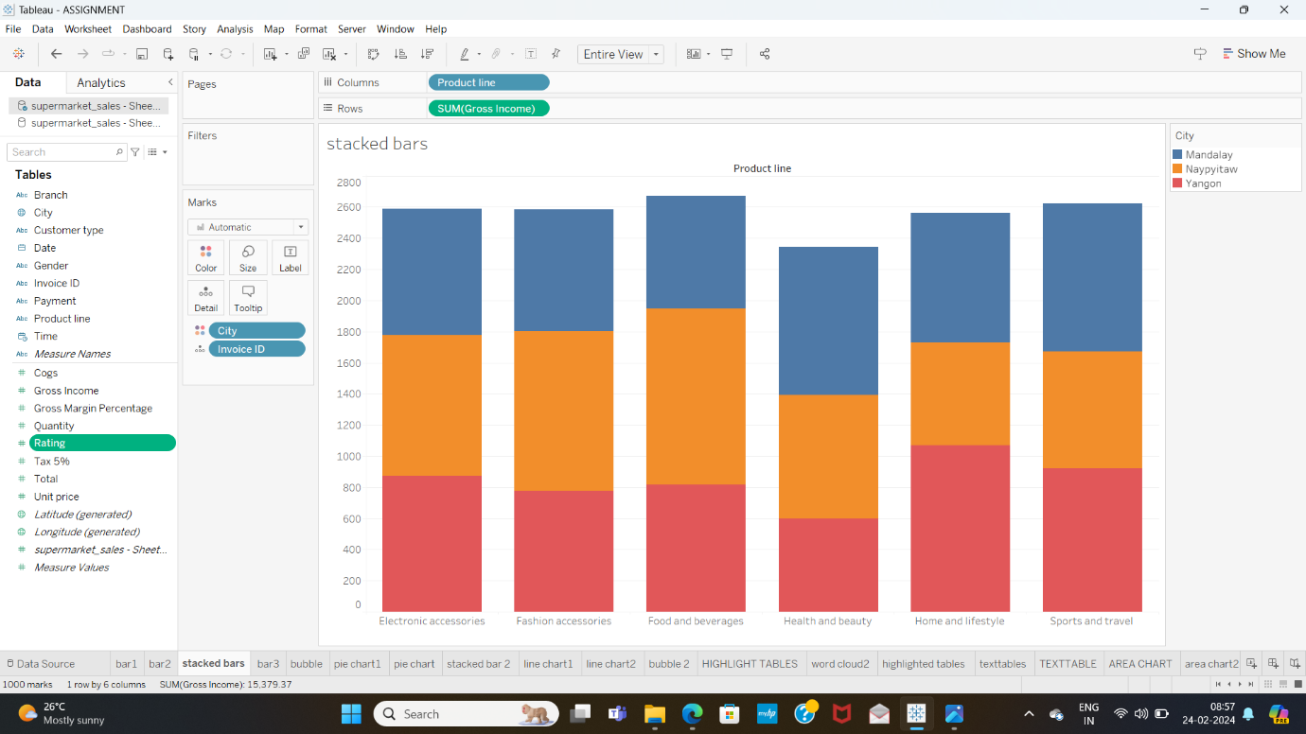

To know the Gross Income of various products across various cities ,I have used stacked bar chart.

LINE CHART

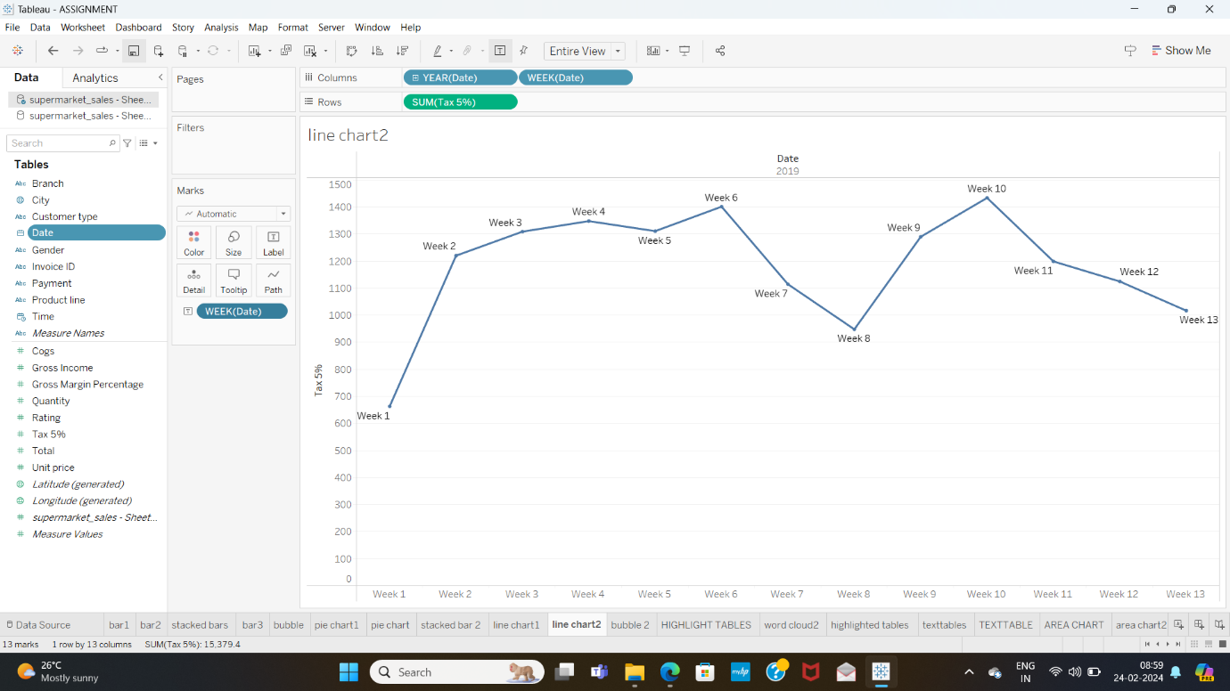

I have used line chart to know the weekly Tax 5% over the year 2019. The highest recorded on week 10 and lowest on week 1 .

PIE CHART

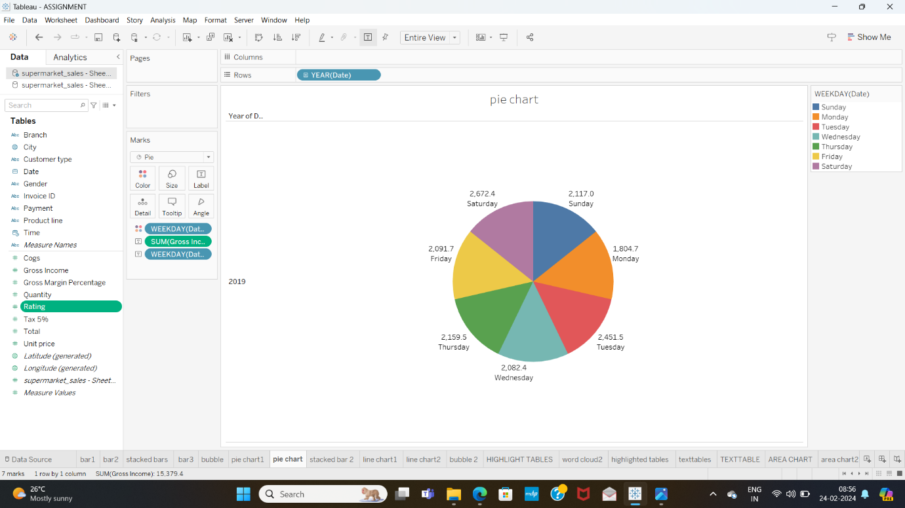

Used pie chart to know the Gross income of a week . Saturday has the highest and Monday has the least.

PACKED BUBBLE CHART

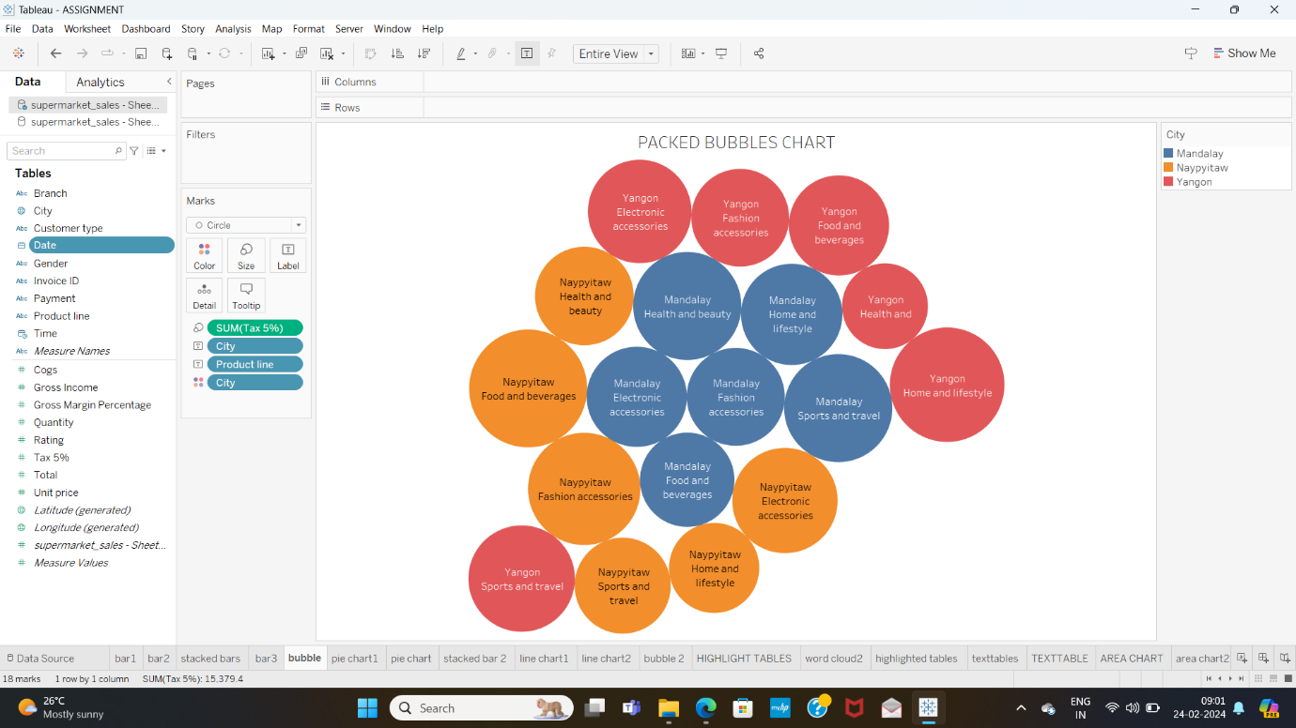

Used packed bubble chart to get the tax 5% over various cities for various products.